Lab 04 – Worksheet

Name: Abdul Moiz Ahmed | ID: aa08811 | Section: T4

Note: Assumptions and logics should be explained separately in tasks after the task results.

Task 1

Provide appropriately commented codes.
#n=5
addi x10, x0, 5

#call the factorial function
jal x1, fact

#move result to x11 to print
addi x11, x10, 0

#print
addi x10, x0, 1
ecall

#skip the function after returning
jal x0, exit

#listing 3.2 code
fact:
addi sp, sp, -8 # adjust stack for 2 items
sw x1, 4(sp) # save return address
sw x10, 0(sp) # save argument n

addi x5, x10, -1 # x5 = n - 1
bge x5, x0, L1 # if (n - 1) >= 0, go to L1

addi x10, x0, 1 # return 1
addi sp, sp, 8 # pop stack
jalr x0, 0(x1) # return

L1:
addi x10, x10, -1 # argument = n - 1
jal x1, fact # recursive call

addi x6, x10, 0 # save result of fact(n-1)
lw x10, 0(sp) # restore original n
lw x1, 4(sp) # restore return address
addi sp, sp, 8 # pop stack

mul x10, x10, x6 # n * fact(n-1)
jalr x0, 0(x1) # return

exit:

*Add snip of relevant Registers / Memory locations where you think results are obtained. Make sure the irrelevant area of snip is cropped. Make sure the irrelevant area of snip is cropped.
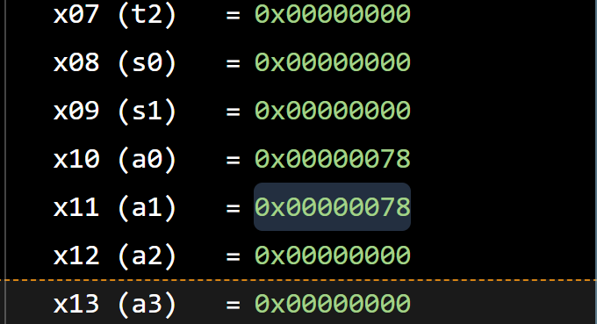

Comments

We tested the factorial function with n = 5 and it returned 120 as the answer which is 0x78 in hexadecimal. The result is stored in register x10 and was also copied to x11 and during each recursive call the stack stores the return address x1 and the current value of n (x10). The stack pointer is decreased by 8 bytes for each call and restored as each recursive call returns

Task 2

Provide appropriately commented codes
#num=5
addi x10, x0, 5

#call ntri function
jal x1, ntri

#coyp result to x11 to pritn
addi x11, x10, 0

#print
addi x10, x0, 1
ecall

jal x0, exit

ntri:
#psace for ra and num
addi sp, sp, -8
#sav ra and num (current)
sw x1, 4(sp)
sw x10, 0(sp)

#x5=1
addi x5, x0, 1

#if num <= 1then go to base case
ble x10, x5, base
addi x10, x10, -1

#recursive call
jal x1, ntri

# save result of ntri(num - 1) and restore orignal num
addi x6, x10, 0
lw x10, 0(sp)

#ra restroe and stack
lw x1, 4(sp)
addi sp, sp, 8

#num+ntri(num-1)
add x10, x10, x6

jalr x0, 0(x1)

base:
#reutnr 1
addi x10, x0, 1
lw x1, 4(sp)
addi sp, sp, 8
jalr x0, 0(x1)
exit:

Add screenshot of your results

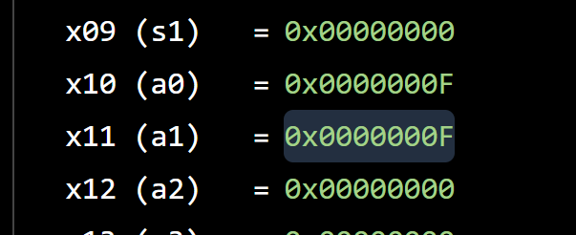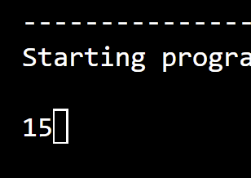

Comments
We tested the function with num =5 and it returned 15 which is 0x0F in hexadecimal. for each recursive call the current value of num and the return address are stored on the stack and the stack pointer is decreased by 8 bytes for each call. When the base case num<= 1 is reached then the function returns 1 and the previous values and return addresses are restored

Task 3

Provide appropriately commented codes
#base add of array
addi x10, x0, 0x200

#len=4
addi x11, x0, 4

#store the array: 3 1 4 2
addi x5, x0, 3
sw x5, 0(x10)

addi x5, x0, 1
sw x5, 4(x10)
addi x5, x0, 4
sw x5, 8(x10)
addi x5, x0, 2
sw x5, 12(x10)
jal x1, bubble

jal x0, exit

bubble:
# if a == 0, return
beq x10, x0, return
# if len == 0, return
beq x11, x0, return
#i=0
addi x5, x0, 0
outer_loop:

# if i >= len, sorting is complete
bge x5, x11, return
#j=i
addi x6, x5, 0

inner_loop:

# if j >= len, move to next i
bge x6, x11, next_i
#find a[i] addres
slli x7, x5, 2
add x7, x10, x7

#find a[j] address
slli x28, x6, 2
add x28, x10, x28

#load a[i]
lw x29, 0(x7)

#load a[j]
lw x30, 0(x28)
# if a[i] >= a[j], do not swap
bge x29, x30, no_swap
#swap a[i] and a[j]
sw x30, 0(x7)
sw x29, 0(x28)

no_swap:
#j=j+1
addi x6, x6, 1

#repeat inner loop
jal x0, inner_loop

next_i:

#i=i+1
addi x5, x5, 1

#repeat outer loop
jal x0, outer_loop

return:
jalr x0, 0(x1)
exit:
jal x0, exit

Add screenshots of your results
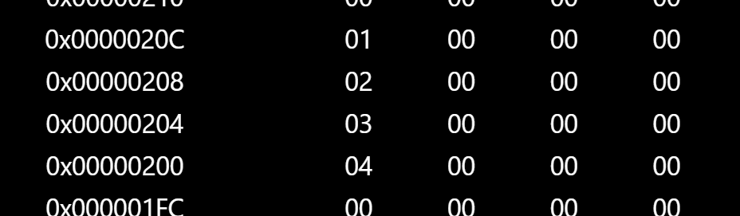

Comments:
We tested the bubble sort function using the array [3, 1, 4, 2] and after execution, the values stored in memory became [4, 3, 2, 1] which shwed that the array was sorted in descending order. we used two loops to compare array elements and swaps them whenever a[i] < a[j]

Task 4

Provide appropriately commented codes

#a=3

addi x10, x0, 3

#b=4

addi x11, x0, 4

#call func

jal x1, calculate

#copy ot x11

addi x11, x10, 0

#proint int

addi x10, x0, 1

ecall

jal x0, exit

calculate:

#make space on stack and save ra

addi sp, sp, -4

sw x1, 0(sp)

#call sum, square fucntions

jal x1, sum

jal x1, square

#restore original ra and stack

lw x1, 0(sp)

addi sp, sp, 4

#return

jalr x0, 0(x1)

sum:

#x10=a+ b

add x10, x10, x11

#return

jalr x0, 0(x1)

square:

#x10=x10*x10

mul x10, x10, x10

jalr x0, 0(x1)

exit:

jal x0, exit

Add screenshots of your results
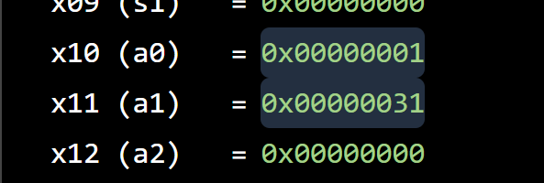

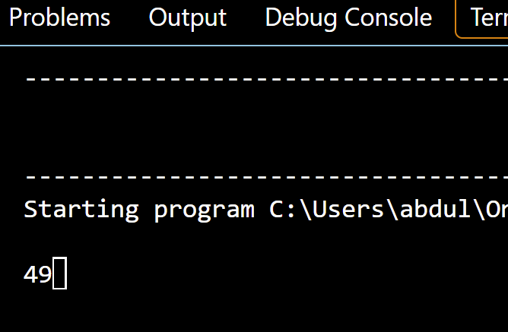

Comments:
For this task, we calculate (a + b)² using nested procedures. For a =3 and b = 4 the sum function calculates 3+4 = 7 and the square fucntion calculates 7×7 = 49. The final result is stored in x11 as 0x31 and printed as 49 in the terminal. The calculate fucntion saves its ra on the stack before calling the nested procedures and restores it

Lab 04 – Nest Procedures and Sorting

Assessment Rubrics

Points Distribution
Task No. | LR2  Code | LR 5  Results | AR 7  Report Submission & Github
Task 1 | /10 | /05 | /10 & /10
Task 2 | /10 | /10 | /10 & /10
Task 3 | /10 | /10 | /10 & /10
Task 4 | /15 | /10
Total Points | /100 Points
CLO Mapped | CLO 2
For description of different levels of the mapped rubrics, please refer the provided Lab Evaluation Assessment Rubrics and Affective Domain Assessment Rubrics.
# | Assessment Elements | Level 1: Unsatisfactory  Points 0-1 | Level 2: Developing  Points 2 | Level 3:Good  Points 3 | Level 4:Exemplary  Points 4
LR2 | Program/Code/ Simulation Model/ Network Model | Program/code/simulation model/network model does not implement the required functionality and has several errors. The student is not able to utilize even the basic tools of the software. | Program/code/simulation model/network model has some errors and does not produce completely accurate results. Student has limited command on the basic tools of the software. | Program/code/simulation model/network model gives correct output but not efficiently implemented or implemented by computationally complex routine. | Program/code/simulation /network model is efficiently implemented and gives correct output. Student has full command on the basic tools of the software.
LR5 | Results & Plots | Figures/ graphs / tables are not developed or are poorly constructed with erroneous results. Titles, captions, units are not mentioned. Data is presented in an obscure manner. | Figures, graphs and tables are drawn but contain errors. Titles, captions, units are not accurate. Data presentation is not too clear. | All figures, graphs, tables are correctly drawn but contain minor errors or some of the details are missing. | Figures / graphs / tables are correctly drawn and appropriate titles/captions and proper units are mentioned. Data presentation is systematic.
AR9 | Report | All the in-lab tasks are not included in report and / or the report is submitted too late. | Most of the tasks are included in report but are not well explained. All the necessary figures / plots are not included. Report is submitted after due date. | Good summary of most the in-lab tasks is included in report. The work is supported by figures and plots with explanations. The report is submitted timely. | Detailed summary of the in-lab tasks is provided. All tasks are included and explained well. Data is presented clearly including all the necessary figures, plots and tables.

